**ASSIGNMENT 3**

1.(50 points) Create a sequence diagram for the Asteroids video game. The diagram should define the main logic of the game in each clock cycle (e.g. clock tick), and the whole game can be seen as a repetition of the logic. Your sequence diagram must include the instances of the following classes: Clock, GameBoard, Player, Asteroid, and GameControl. Feel free to add more participants if you think it is necessary.

2. (30 points) Create a state diagram for the GameControl class. It must include at least four states: GameOver, GamePaused, MovingToNextLevel, and NewGame. For each state, include state name and activity when applicable. For each transition, include event, guard, and activity when applicable.

**Sequence Diagram:** I have added all the required participants. After initializing there will be three activities mentioned below which will execute in parallel before game ends.

These are:

1. According to user actions that are keys pressed, the gameGUI handles the events.
2. When clock tick will get over, more asteroids will be added, UFO will be timely when levels are up and required as per game logic, level will get up.
3. Detecting collisions and taking proper action when collision occur.

At last user will see high score and total score.

**State Diagram:** I have mentioned all the required transitions and states. States are below:

New state: It will occur when user selects play game option. It will initialize everything.

Play state: It will handle all the user actions, render GUI and checking for clock.

Game paused state: it will happen when user will selects pause option

Moving to next level: when clock will get over then level will get up means the velocity of asteroids will increase and also their number.

Game over state: when player lives get zero , this state will occur. Also user can reset game from this state.

**SEQUENCE DIAGRAM:**

x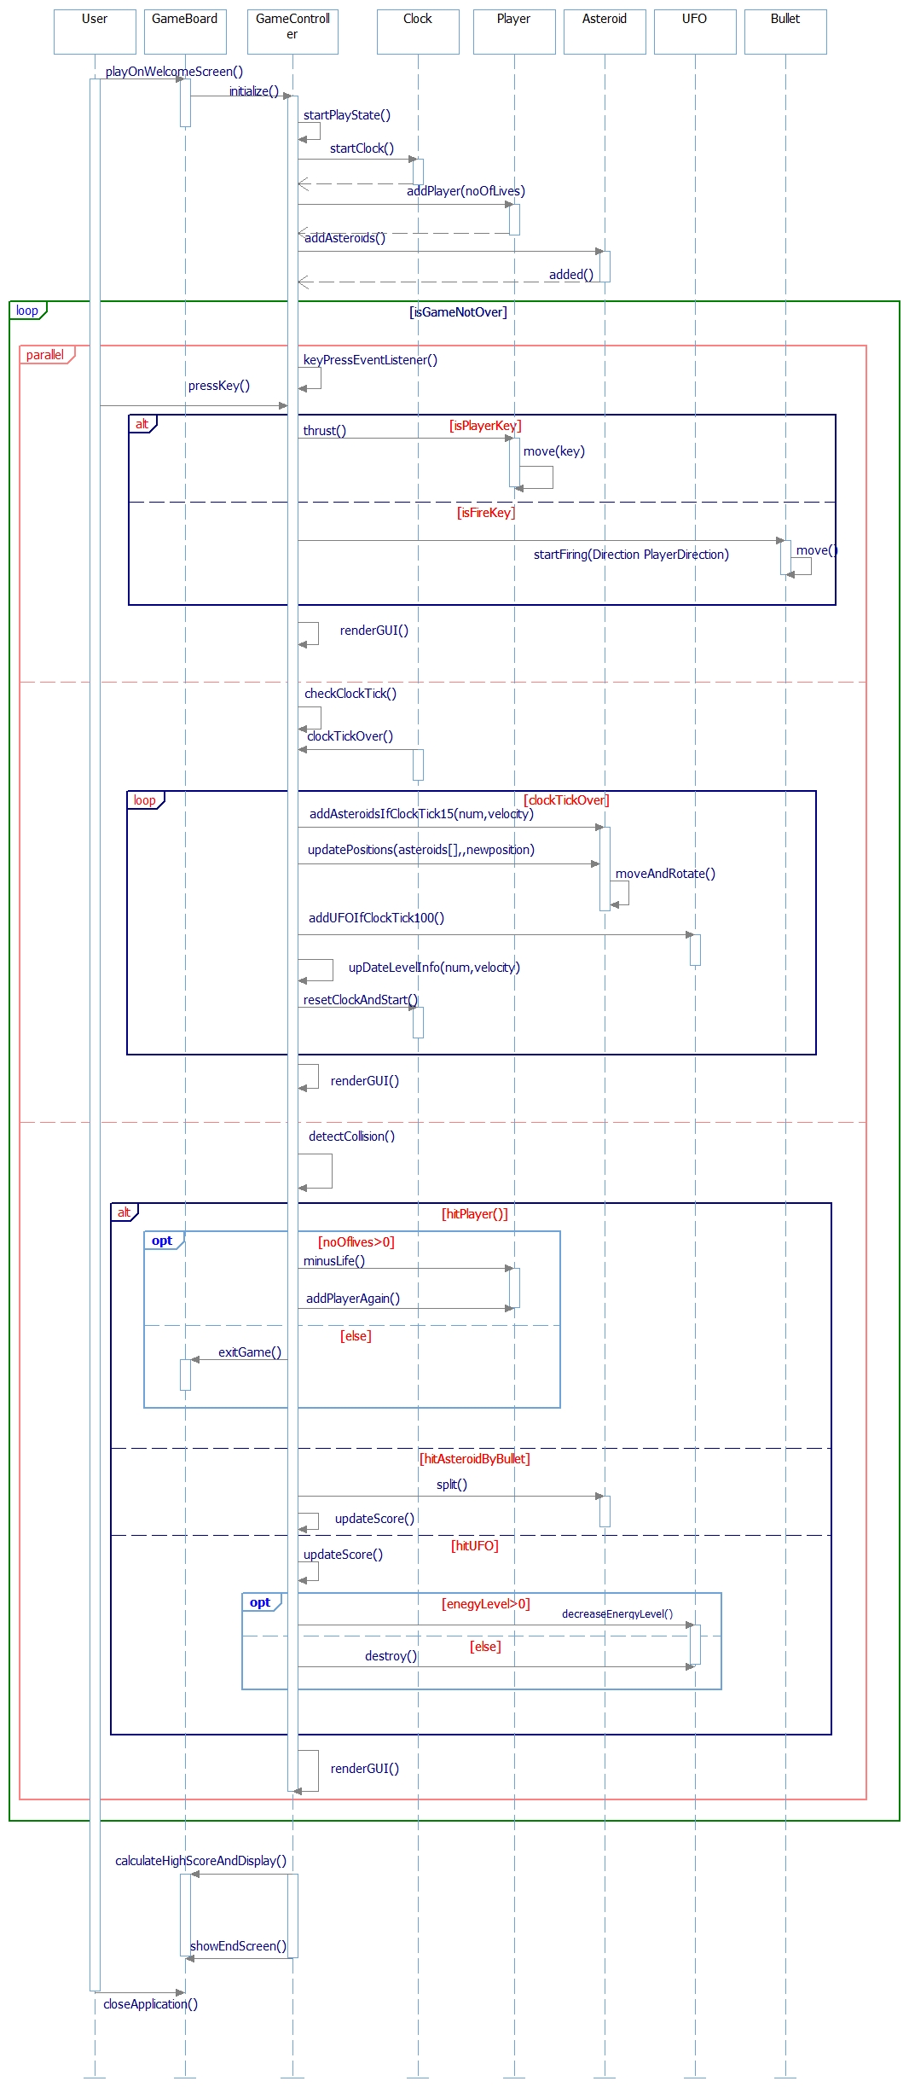

**STATE DIAGRAM for GAMECONTROL:**

